Kountze Public Library’s
Texas Summer Reading Club 2016
Theme is “On Your Mark, Get Set…Read”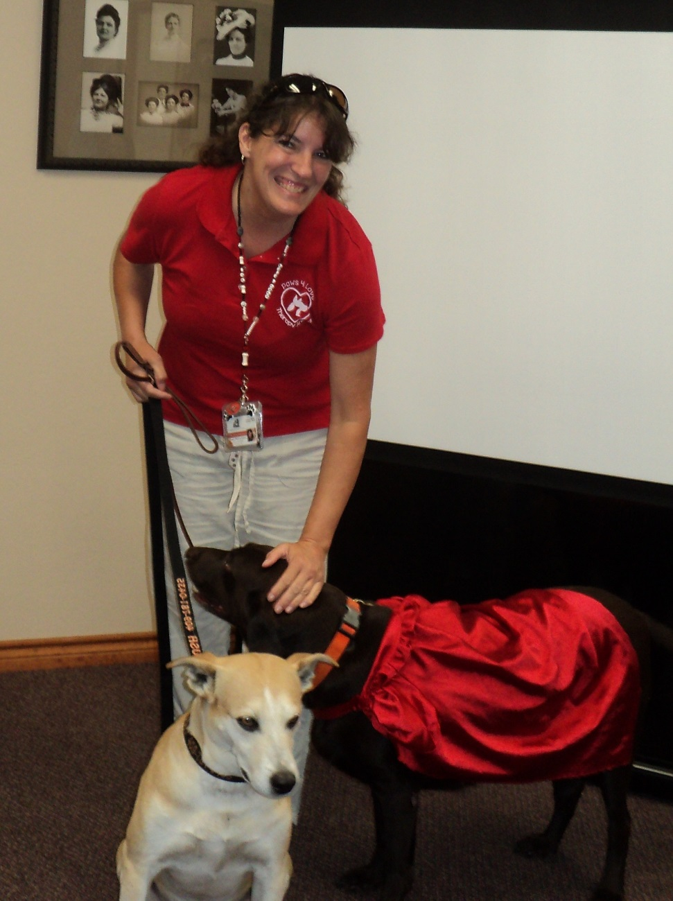
First Program is Tuesday, June 7 @ 10AM in
the Bevil Meeting Room of the Library.
Special guests are Mrs. Bevilacqua, son Lane
and Crush & Riley (therapy dogs)

